PRICE LIST FOR PARTNERS
As of January 1st, 2014
Flax fabric
Mattresses for children

Size, cm |  |  | Price € |  |  | Recommended price € |  | Notes
80х35х2 |  |  | 9-00 |  |  |  |  | Composition: flax
120х60х6 |  |  | 20-50 |  |  |  |  | Composition:flax/2 layers of wool/flax
120х60х7 |  |  | 38-00 |  |  |  |  | Composition: flax/coconut/flax
Universal Mattress 120х60х7 |  |  | 30-00 |  |  |  |  | Composition: flax/3 layers of wool/flax
140х70х6 |  |  | 27-00 |  |  |  |  | Composition: flax/2 layers of wool/flax
Lux Mattress 120х60х6 |  |  | 61-00 |  |  |  |  | Composition:12 layers of needle-punched flax
Mattresses for adults

Mattress «Topper»

Size, сm | Price € |  |  |  | Recommended Price € |  |  | Notes
190 х 70 х 4 | 29-00 |  |  |  |  |  |  | 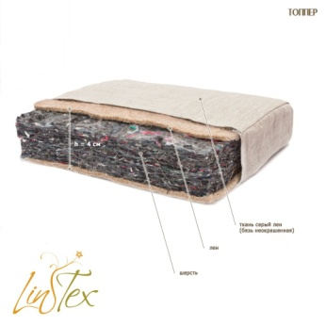
190 х 80 х 4 | 32-00
190 х 90 х 4 | 36-00
190 х 100 х 4 | 39-00
190 х 110 х 4 | 43-00
190 х 120 х 4 | 47-00
190 х 140 х 4 | 54-00
190 х 160 х 4 | 60-00
200 х 160 х 4 | 63-00
190 х 180 х 4 | 68-00
200 х 180 х 4 | 71-00
Mattress «Futon»

Size, сm | Price  € |  |  |  | Recommended Price € |  |  | Notes
190 х 70 х 6 | 32-00 |  |  |  |  |  |  | 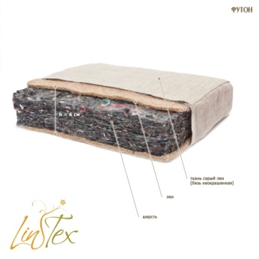
190 х 80 х 6 | 36-00
190 х 90 х 6 | 40-00
190 х 100 х 6 | 44-00
190 х 110 х 6 | 47-00
190 х 120 х 6 | 51-50
190 х 140 х 6 | 59-50
190 х 160 х 6 | 67-00
200 х 160 х 6 | 70-00
190 х 180 х 6 | 76-00
200 х 18 0х 6 | 78-50
Matress pad with angle fixators
Size, cm | Price € |  |  |  | Recommended Price € |  |  | Notes
120х60 | 16-00 |  |  |  |  |  |  | 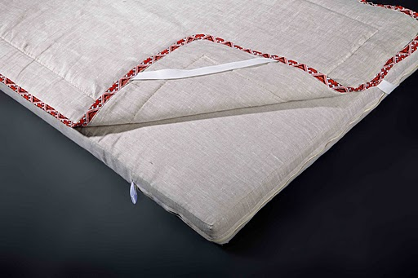
140х70 | 18-00
190х70 | 23-00
190х80 | 25-00
190х90 | 27-50
190х100 | 32-00
190х110 | 35-00
190х120 | 36-00
190х140 | 42-00
190х160 | 46-00
200х160 | 48-00
190х180 | 51-00
200х180 | 52-00
Blanket in eco pack

Size (cm) | Price € |  |  |  | Recommended Price € |  |  | Note: 100% needle-punched flax
140х110 | 25-00 |  |  |  |  |  |  | 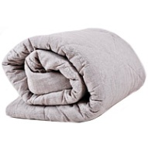
140x205 | 44-50
215х155 | 51-00
210х175 | 56-00
220х200 | 63-00
Pillows 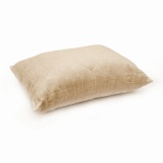 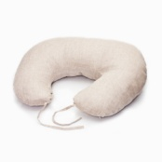

Size, см | Price (uah) |  |  |  | Recommended Price € |  |  | Notes
35х35 | 6-00 |  |  |  |  |  |  | Children pillow for baby-carriage
35х55 | 6-50 |  |  |  |  |  |  | Children pillow for bed
40х60 | 10-00 |  |  |  |  |  |  | Filler – hollofiber/flax
40х60 Eco pack | 13-00 |  |  |  |  |  |  | Filler – Flax fiber
50х70 | 13-00 |  |  |  |  |  |  | Filler – hollofiber/flax
50х70 Eco pack | 17-00 |  |  |  |  |  |  | Filler – Flax fiber
70х70 | 18-00 |  |  |  |  |  |  | Filler – hollofiber/flax
70х70 Eco pack | 20-50 |  |  |  |  |  |  | Filler – Flax fiber
Travel pillow | 9-00 |  |  |  |  |  |  | Filler – hollofiber/flax
Children travel pillow | 4-00 |  |  |  |  |  |  | Filler – hollofiber
Pillow for feeding | 35-00 |  |  |  |  |  |  | Filler- hollofiber/flax
Orthopedic rolls

Size, cm | Price € |  |  |  | Recommended Price € |  |  | Notes
Neck roll | 7-50 |  |  |  |  |  |  | 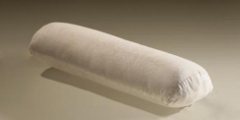
Lumbar roll | 9-00
Ankle roll | 11-50
Office chair roll | 7-50
Eco packed linen

Name  Size (cm) |  | Price € |  |  | Recommended Price € |  |  | Notes
BED LINEN 140х110 |  | 31-00 |  |  |  |  |  | Pillow case 40х60cm -1 piece, Sheet 80х140 cm, Blanket case 110х140 cm-1 piece
BED LINEN 205х140 |  | 54-00 |  |  |  |  |  | Pillow case 50х70cm-2pieces, Sheet 140х225 см-1 piece, Blanket case 140х205 cm-1 piece
BED LINEN 210х175 |  | 67-00 |  |  |  |  |  | Pillow case 50х70 cm-2pieces, Sheet 195х230 cm-1piece, Blanket case 175х210 cm-1 piece
BED LINEN 215х155 |  | 61-00 |  |  |  |  |  | Pillow case 50х70 cm-2pieces, Sheet 175х235 cm-1 piece, Blanket case155х215 cm-1 piece
BED LINEN 220х200 |  | 75-00 |  |  |  |  |  | Pillow case 50х70 cm-2 pieces, Sheet-220х240 cm-1piece, Blanket case 200х220 cm-1 piece
BED LINEN «Family» |  | 105-00 |  |  |  |  |  | Pillow case 50х70-4 pieces, Sheet 200х220 cm-1 piece, Blanket case 145х210-2 pieces.
BED LINEN 140х110 with decoration |  | 39-00 |  |  |  |  |  | Pillow case 40х60cm -1 piece, Sheet 80х140 cm, Blanket case 110х140 cm-1 piece
BED LINEN 205х140 with decoration |  | 64-00 |  |  |  |  |  | Pillow case 50х70cm-2pieces, Sheet 140х225 см-1 piece, Blanket case 140х205 cm-1 piece
Sheet 140х110 |  | 9-00
Sheet 205х140 |  | 15-00
Sheet 215х155 |  | 16-00
Sheet 210х175 |  | 20-00
Sheet 220х200 |  | 22-50
Blanket case 110х140 |  | 20-00
Blanket case 205х140 |  | 31-00
Blanket case 215х155 |  | 33-50
Blanket case 210х175 |  | 41-00
Blanket case 220х200 |  | 47-00
Pillow case 35х35 |  | 3-00
Pillow case 35х55 |  | 4-00
Pillow case 45х45 |  | 4-50
Pillow case 35х80 |  | 5-00
Pillow case 40х60 |  | 4-50
Pillow case 50х70 |  | 6-00
Pillow case 50х70 |  | 8-00 |  |  |  |  |  | «Oxford»
Accessories

Name  Size (cm) |  |  |  | Price € |  |  | Recommended Price € |  | Notes
Rug 45х45 |  |  |  | 8-00 |  |  |  |  | 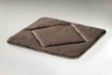
Car seat cape |  |  |  | 15-00 |  |  |  |  | 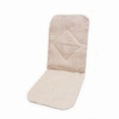
Baby mattress for a car seat |  |  |  | 14-00 |  |  |  |  | In assortment: for groups 0+, 1+,2,3
Bed protection in eco pack |  |  |  | 26-00 |  |  |  |  | 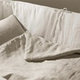
Pillow-toy |  |  |  | 6-00 |  |  |  |  | 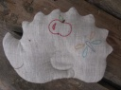
Towel 50х70 |  |  |  | 4-00
Towel 50х70 (lace) |  |  |  | 4-50 |  |  |  |  | Towel with decoration
Gown for sauna |  |  |  | 16-00 |  |  |  |  | 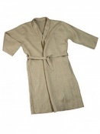
Curtain 50х70 |  |  |  | 7-00 |  |  |  |  | 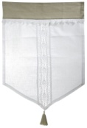
Curtain 50х120 |  |  |  | 9-00 |  |  |  |  | Curtain with decoration
Pillow-hotty |  |  |  | 5-00 |  |  |  |  | Stuffed with flax seeds
Bag for toys |  |  |  | 4-00 |  |  |  |  | 73х43х16R
Sleeping bag 70х40 |  |  |  | 9-00 |  |  |  |  | 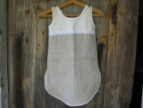
Night gown |  |  |  | 15-00

We manufacture products also in individual order.
LinTeks Ltd. Manufacturing Company
phone: +38 097 2585740 (Manager Oksana)
tel. 050-4438748
E-mail: lintexoksana@gmail.com
www.matras.in.ua
www.lintex.com.ua

Patent No. 457, No. 481, No. 40061, No. 78535
Important: only 100% needle-punched linen without any synthetic additives is used in all products!

